Elérhető a HUN-REN decemberi stratégiai workshopján készült, a világ élvonalába tartozó meghívott kutatók előadásait is tartalmazó videó
A 2023. december 13-án megrendezett HUN-REN Stratégiai Workshop II. rendezvényünkön a HUN-REN terveinek és célkitűzéseinek bemutatása mellett a világ élvonalába tartozó meghívott külföldi kutatók egy-egy vezető ország KFI ökoszisztémájához kapcsolódó témákról, legjobb gyakorlatokról tartottak előadásokat, amelyeket élőben közvetítettünk. Az erről készült videó már elérhető a HUN-REN YouTube-csatornáján és a honlapunkon.
Strategic Workshop II.
1:16 – 12:20Opening Remarks: Balázs GULYÁS, President of HUN-REN
12:37 – 47:42Technology-based Breakout Points of the Hungarian Economy: László GYÖRGY, Government Commissioner responsible for professional cooperation in economic strategic tasks and coordination of the Let’s Teach for Hungary programme
48:06 – 1:14:19Assessment Process of the HUN-REN Institutes: Alexander J.B. ZEHNDER, Professor Emeritus at ETH Zurich, Former President of the Board of the ETH-Domain, and founder and director of Triple Z Consulting, Chairman of the HUN-REN Advisory Board
1:14:30 – 1:24:19Self-assessment of the Institutes and Research Centres: István SZABÓ, Strategic Advisor to HUN-REN
1:24:29 – 1:49:06Sustainability and the Research, Innovation and Enterprise Ecosystem: Steve EVANS, Director of Research in Industrial Sustainability at the University of Cambridge, Professor of Supply Chain Sustainability at the Royal College of Art, Professor at the Cranfield School of Management, member of the HUN-REN Advisory Board
1:49:09 – 2:03:02Chains and Grids in Research and Production: Johann-Dietrich WÖRNER, President of Germany’s acatech – the National Academy of Science and Engineering
2:03:03 – 2:30:27The German Research and Innovation Ecosystem – Strengths and Weaknesses: Michael KASCHKE, Chairman of the Supervisory Board of the Karlsruhe Institute of Technology (KIT) and President of the Association for the Promotion of Science and Humanities in Germany, member of the HUN-REN Advisory Board
2:30:45 – 2:52:22The American Research and Innovation Ecosystem in Academia: István MÓDY, the Tony Coelho Distinguished Professor of Neurology and Distinguished Professor of Physiology at the David Geffen School of Medicine at UCLA, part-time Professor at the Department of Epileptology at the Bonn University Medical Center, member of the HUN-REN Advisory Board
2:52:27 – 3:22:17Israel’s Research and Innovation Ecosystem: Avi DOMB, Chief Scientist at Israel’s Ministry of Science and Technology
3:22:47 – 3:46:29The Korean Research and Innovation Ecosystem: Nam-Joon CHO, the MRS-Singapore Chair Professor in the School of Materials Science and Engineering and Director of Flagship Programmes at Nanyang Technological University in Singapore, President of the Korean Scientists and Engineers Association in Singapore, member of the National Academy of Engineering of Korea, member of the HUN-REN Advisory Board
3:46:39 – 4:19:57Global Partnerships in Research and Innovation – the Singapore Perspective: Subodh MHAISALKAR, Professor, Nanyang Technological University, Singapore
4:20:01 – 4:43:54The John von Neumann Programme: László BÓDIS, Deputy State Secretary responsible for innovation, Ministry of Culture and Innovation
4:44:03 – 5:04:39International Benchmarks, Best Practices and Barriers in the Field of Research and Innovation: Sierd CLOETINGH, distinguished professor at the University of Utrecht, former President of Academia Europaea, former President of the Association for European Cooperation in Science & Technology (COST) and former Vice-President of the European Research Council (ERC), member of the HUN-REN President’s Circle
5:04:49 – 5:28:58Invited Remarks: Members of the HUN-REN Advisory Board and President’s Circle – President Balázs Gulyás, Professor Éva Kondorosi, Ms. Melanie Seymour, Sir Philip Campbell, Professor Sierd Cloething and Mr. David Goldman
5:29:02 – 5:53:42Unleashing the Full Potential of HUN-REN: Roland JAKAB, Chief Advisor and member of the HUN-REN Governing Board
5:53:58 – 6:15:23Key Takeaways & Summary: Balázs GULYÁS, President of HUN-REN
Sajtókapcsolat:
- Hencz Éva, kommunikációs igazgató
- +36 30 155 1803
- media@hun-ren.hu
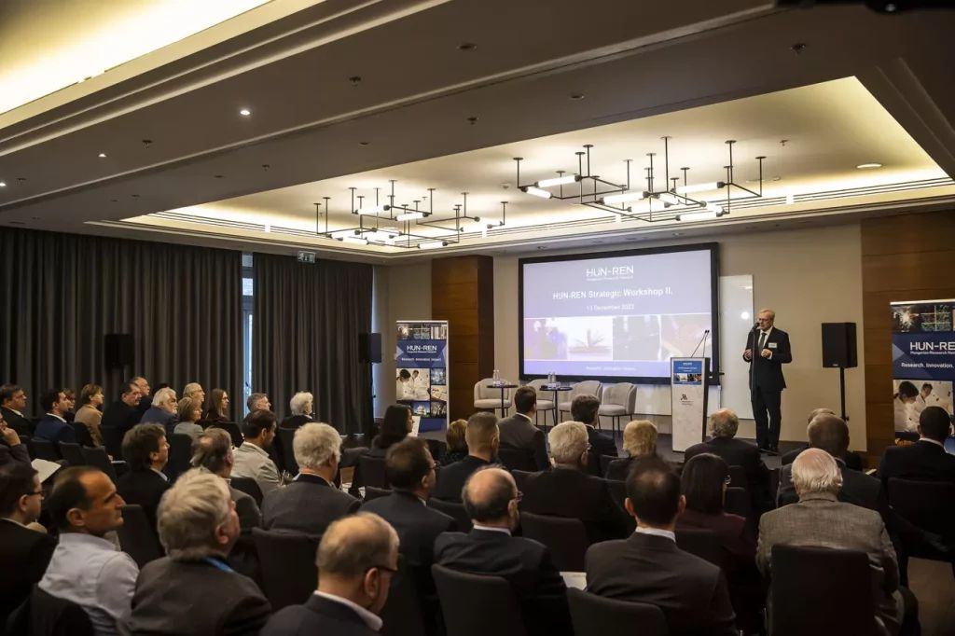 | © HUN-REN
Eredeti tartalom: HUN-REN Magyar Kutatási Hálózat
Továbbította: Helló Sajtó! Üzleti Sajtószolgálat
Ez a sajtóközlemény a következő linken érhető el:

